Greetings,
We are excited to hear about your interest in our program! Come join our class in the Fall!
Apply here for Endoscopy Technician:
Coleman Student Application Version 565.0
Apply for this scholarship:
Connect 2 Workforce Scholarship | Houston City College
We now are eligible for the Connect scholarship. Sign up and complete the intent forms for the scholarship.
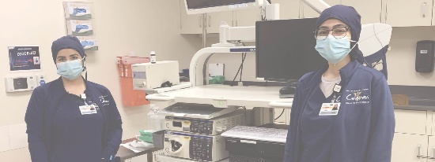 | INFO SESSION: Endoscopy Technician  If you have any questions regarding this information session, please contact our support team at healthscience.info@hccs.edu or call 713.718.8070. You may speak directly with a Coleman campus advisor via Zoom link (https://us02web.zoom.us/j/86185970156) Monday through Thursday, 9 a.m.-6 p.m. and Fri...  hcc.idloom.events

The following two courses are the prerequisites of the Endoscopy Technician program. Courses must be taken and passed before being accepted into the program.
Please also email me to learn more about the program and speak with program director Melissa Bruton at melissa.bruton@hccs.edu.
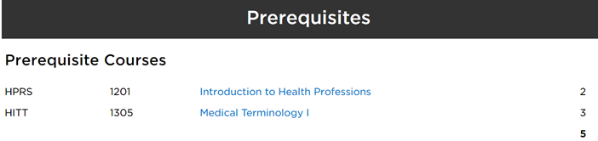
If you have any academic question, please contact program
academic advisor Dr. Terrell Wilkerson. He can be contacted at terrell.wilkerson@hccs.edu or by phone at (713)718-8747.
Here is the website:
Endoscopy Technician | Houston City College
If you have program questions, we would be glad to answer. We can be contacted at (713)718-5990.
To contact the instructor Amecia Swoope please email at amecia.swoope@hccs.edu
Immunizations vaccines and titers required:
- Immunization record showing (Monitored By Complio: houstoncccompliance.com): Completion of Hepatitis B immunization series (may take up to 6 months) and titer, MMR – 2 shots and titer, Tdap – every 10 years, TB – every year, Varicella – 2 shots and titer, Meningitis (required for students 22 years or younger), and Influenza – it is available after September 1st.
Required CPR American Heart Association Healthcare Provider:
- Find one on your own
- Or contact provider Dr. Jackson @ herbert.jackson@hccs.edu
Required Personal Health Insurance-you will not attend clinical without insurance:
- The college does not offer health insurance. You can google and find one that fits your needs. Some students have said the affordable care act has met their needs.
Required passing of drug screen and background check:
- Information given once accepted in program and purchase of Complio. Location and forms located in Complio.
Required physical:
- Information given once accepted in program and purchase of Complio. Form is located in Complio.

If you have any additional questions, I would be happy to answer. Please feel free to contact me via email melissa.bruton@hccs.edu or call 713-718-5990.

