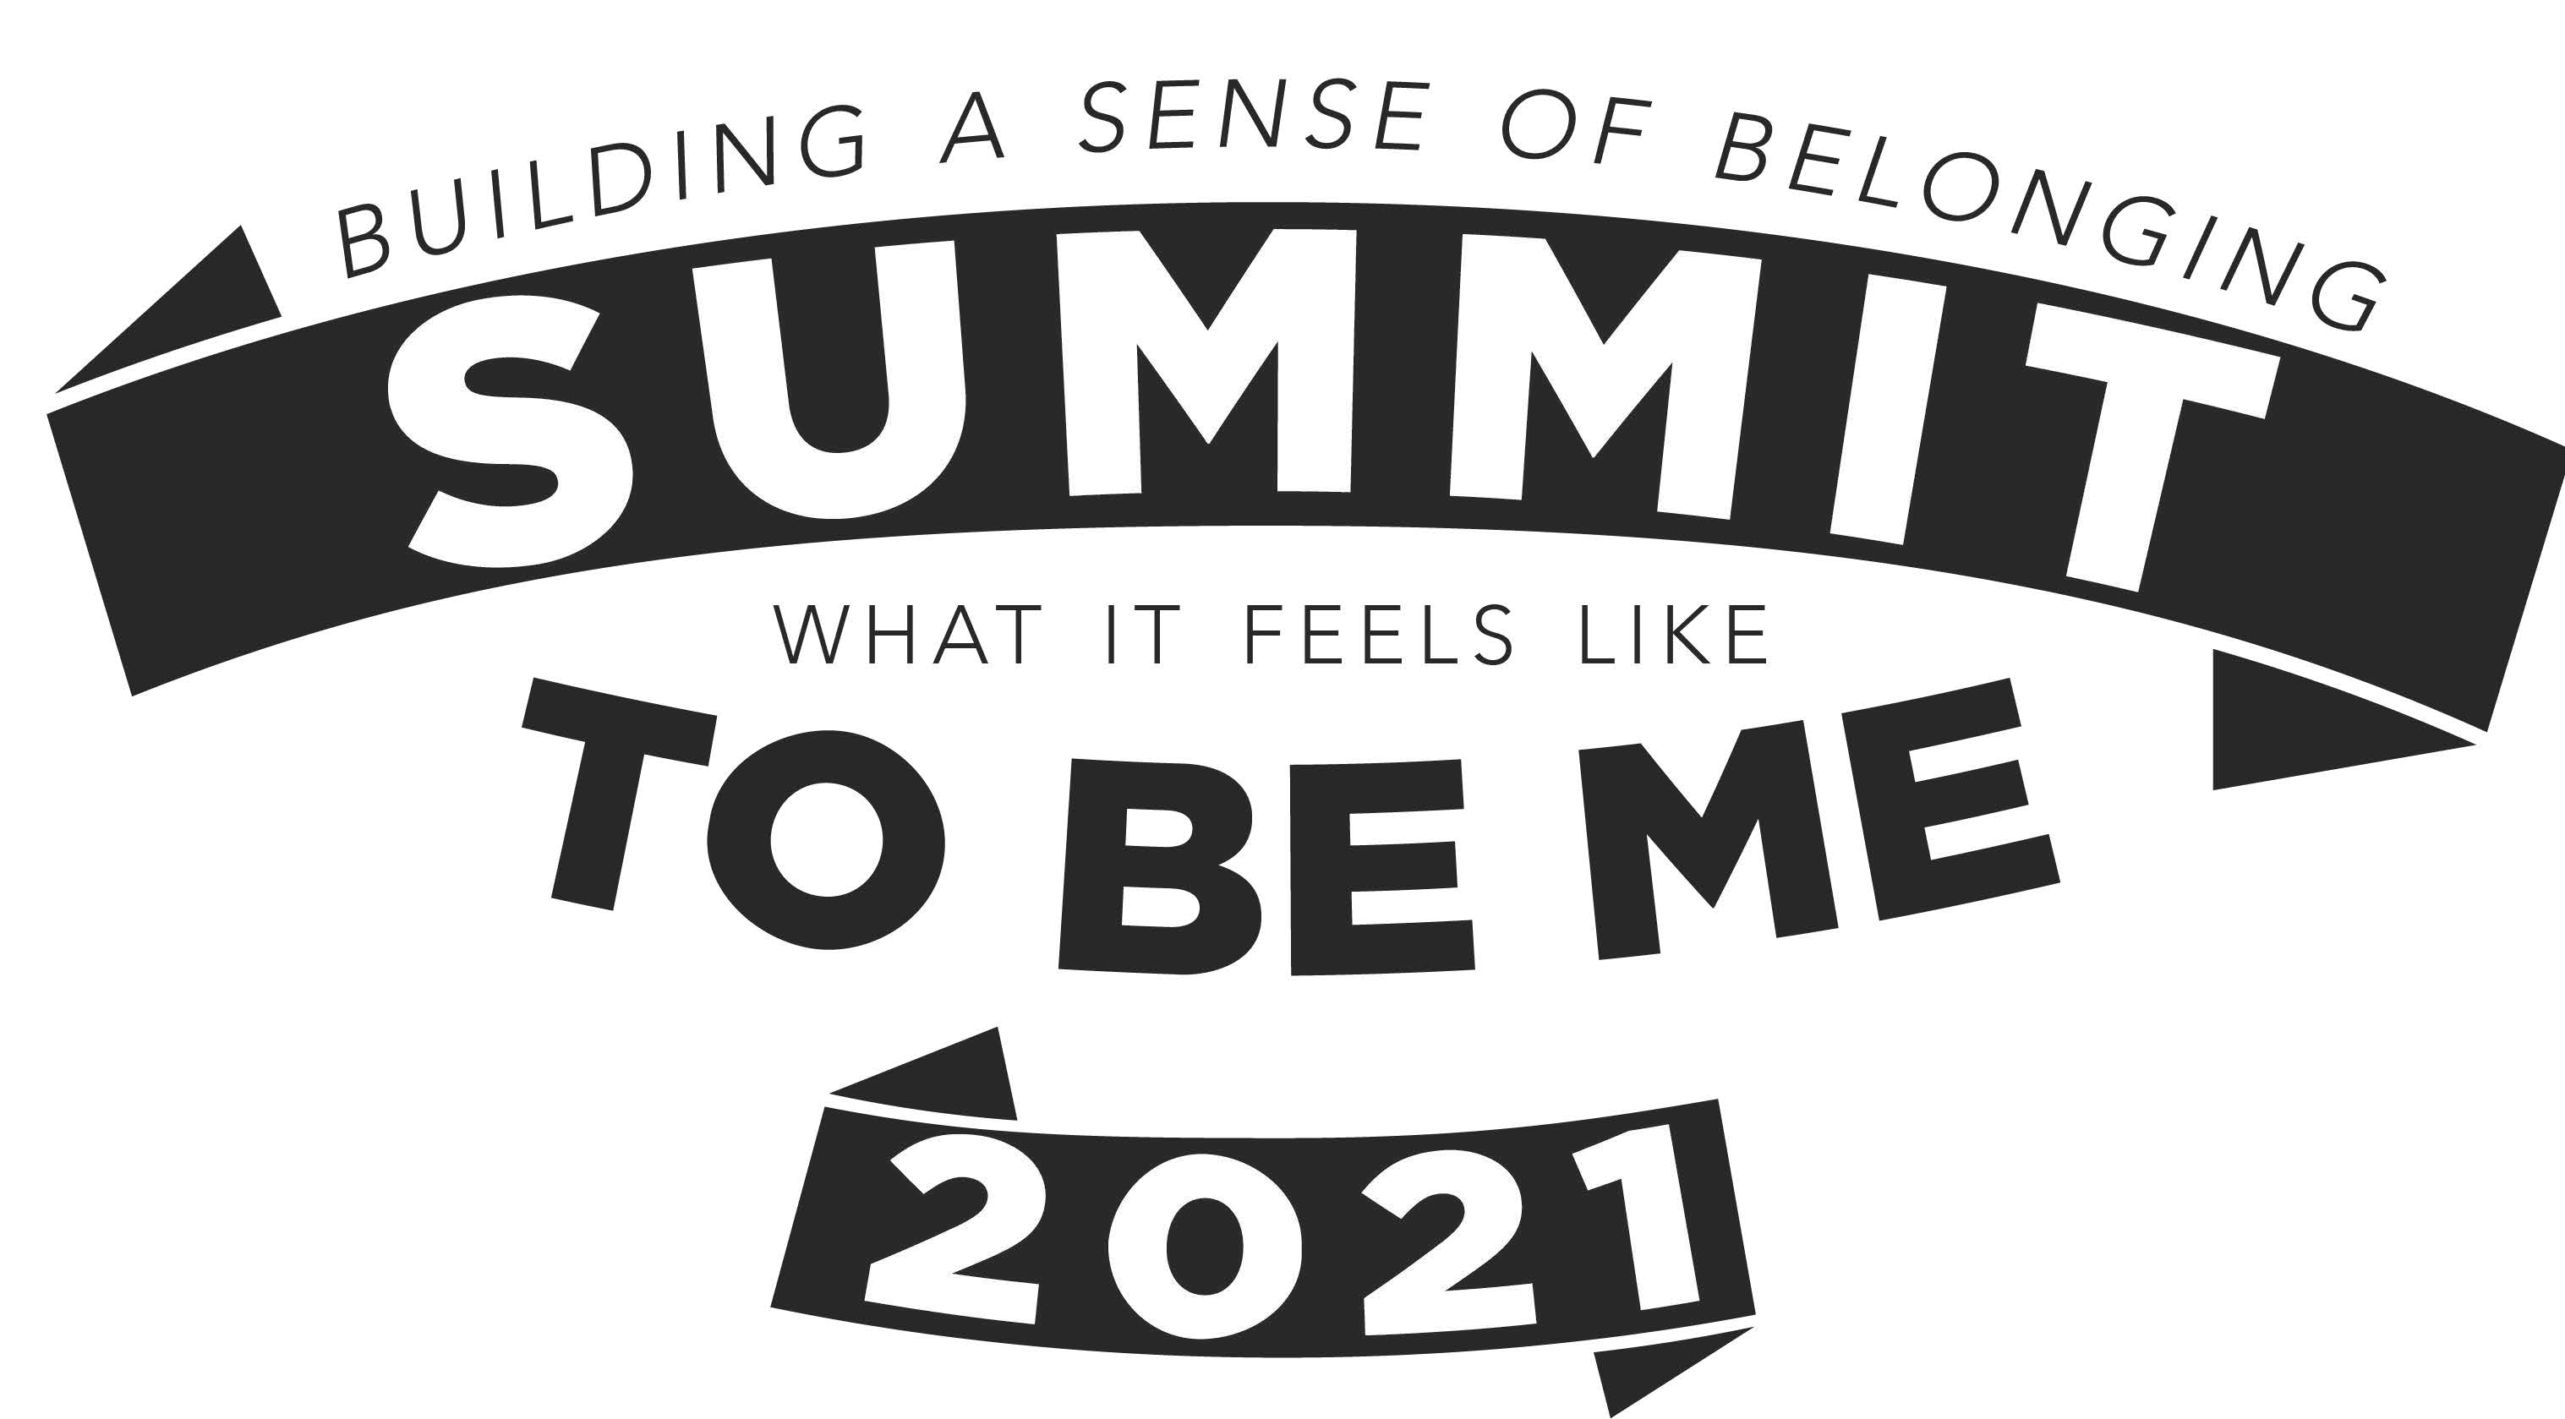

# HCC Students and Community Advocates:

| Elizabeth Singleton | Uchenna Oramulu |
| --- | --- |
| Leon Hosea | Nicole Kwan |

## Rio Gonzales

# Expert Panel:

## Lucie Tredennick Osvaldo Gomez

## Sofia Pertuz Marina Guerra